Journey West

Biographies

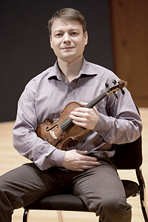
Max Buckholtz, Director
Violin
Max Buckholtz began playing the violin at the age of three under the direction Mary Cay Neal (the founder of The Buffalo Suzuki Strings) with whom he toured beginning at the age of ten to: England, Scotland, Netherlands, France, Switzerland, Germany, Italy, The Former Soviet Union and Hungary under Dr Shinichi Suzuki's philosophy of world peace through music.
Max has worked for the Dance Department at Cornell University since the mid 90's serving as a Dance Accompanist, Performer and Composer. He has also served as a guest/artist lecturer at Cornell University and Ithaca College lecturing and performing Jewish Moldavian, Romanian Lauteri, Turkish and Indian Music, and has advised students participating in The National String Project at SUNY Potsdam: Crane School of Music. Other appointments include accompanying dance installations in Rome, Italy and collecting Jewish Moldavian Music from Botosani, Romania with a grant from Ithaca College.
Last spring Max collaborated and composed music to go along with selected readings and spoken word from internationally renowned Fulbright Scholar Indian Author Kiran Nagakar in a program entitled There is Only One God and Her Name is Life. This program aimed to transcend misunderstandings between those of differing religious backgrounds.
Max currently serves as the Principal Violist for the Orchestra of the Southern Finger Lakes, as a lecturer at Ithaca College and a Dance Accompanist at Cornell University.
In addition to his academic life Max is involved in music education and self publishes ethnic string scores through newdaymusicscores.com to expose children to the idea of multi-culturalism.
As part of his enthusiasm for music of different cultures, Max leads the Klezmer youth band Ithaca is Klezmer which is entering its third year of existence.The band is a fun way for children to expand their musical abilities and gain a rich cultural experience. As part of efforts to preserve cultural music, Mr. Buckholtz and his colleagues have recorded music from old Roma, Romanian and Jewish people in Romania, transcribing the songs, and archiving the music. Through Ithaca is Klezmer, Mr. Buckholtz is keeping the Old World music alive by teaching interested youth how to play klezmer. Over the past two years, the band has performed at venues such as Ithaca Festival, Ithaca College, Porchfest, Kol Haverim events and holiday celebrations, story-telling night at Temple Beth El, on the local radio show Rootabaga Boogie, and more.

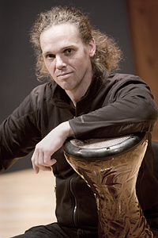
Nikolai Ruskin
Percussion, Oud, Nay
Nikolai Ruskin is a composer and multi-instrumentalist specializing in Middle-Eastern music. Nikolai grew up in the San Francisco Bay area as a visual artist and illustrator, discovering his interest in music at age 22. Upon discovering the percussion instruments of the Middle East, he began an intensive study of Arabic, Turkish and Persian traditional music, as well as classical Indian rhythms. Within one year of setting out on this path, Nikolai began teaching percussion and was soon exploring the melodic instruments of the Middle East. He is now a recognized educator on several instruments including the oud, nay, mizmar, riq, darbuke and def.
In 2002, Nikolai co-founded the Cornell Middle Eastern Music Ensemble and was musical director of the group until 2006. He has been an accompanist for the East Indian Classical Dance and Movement Explorations programs at Cornell Theatre Arts since 2000 and has lectured at Ithaca's Community School of Music and Arts and Cornell Music Department. Nikolai was also an artist-in-residence at Cornell's Risley Hall and continues to teach group and private lessons.
Nikolai has performed with numerous musicians from Arabic and Turkish backgrounds, and currently performs with the bands Gadje and SOUK: Middle Eastern Grooves.

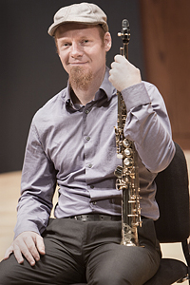
Mark Karlsen
Saxophone, Clarinet, Flute
Mark Wienand is a saxophonist and multi-instrumentalist hailing from Ithaca, NY. He has been playing saxophone for nearly thirty years, and has earned both BM (North Carolina School of the Arts) and MM (Ithaca College) degrees in Classical Saxophone Performance. He has also been a middle school band director and college music professor.
Mark's musical exploits in Ithaca include playing many styles of music with several bands including The Hog-Tie Sessions (celtic, bluegrass and folk music of many traditions), The Temple Rockers (Jewish Reggae band with albums on Tzadik records, Solsice (Original R&B and Reggae), The Mutron Warriors (funk), and Thousands of One (Original Ithaca music).
As part of Thousands of One, Mark has been a regular performer at many benefit concerts to support various community organizations in Ithaca over the last several years, including the Southside Community Center and Congo Square Market, Ithaca Biodiesel, GIAC, The Race Liberation Alliance, Healthy Food for All, Big Splash (anti-fracking benefits held in Hector, and Binghamton NY), the Paul Schreurs memorial program, the Ithaca Free Clinic among others.

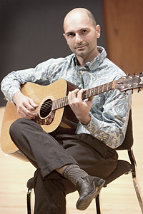
Dara Anissi
Guitar, Mandolin
Dara Anissi was born in Tehran, Iran on October 11, 1973 and moved to the United States in 1975 as his family escaped the oppressive regime of the Ayatollah Khomeini. He began playing the guitar at age five and continued to play for the next thirty-five years, adding a wide variety of instruments and styles to his repertoire.
Dara attended the Ithaca College Music Conservatory from 1991-1995 where he received a Bachelor's in Music composition. During this time he also studied classical guitar privately with Ed Flower. Dara is one of the founding members of The Hog-Tie Sessions in which he plays the acoustic guitar, Celtic-style mandolin, and tenor banjo. Dara also performs with The Cornell Middle Eastern Ensemble and the middle-eastern group Souk, where he plays the dumber and oud. He also writes and performs with his own middle-eastern-influenced rock band.
Dara sees playing, composing, and exploring music as the primary focus in his life and he believes that music is a unifying force for the world. Dara currently teaches music at the Lehman Alternative Community School in Ithaca, NY.
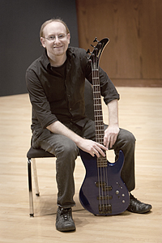

Chad Lieberman
Bass, Accordion
Chad Lieberman studied music composition and electronic music at Ithaca College. He plays piano, accordion, keyboards, bass, and guitar for many of the region's best-known bands. Chad grew up in Miami, Florida, where, as a teenager, he was inspired by Cuban salsa and merengue, as well as the innovative music coming out of the University of Miami's jazz program. These early influences fostered an appreciation for the music of different cultures as well as an awareness of the difficulties that can arise between them. In high school he formed his first band, The Hollow Men, which raised $3000 in ticket sales for the Miami City Mission, a shelter for homeless men.
Chad has performed with many notable Ithaca musicians including Hank Roberts, Kevin Kinsella, Eric Aceto and Richie Sterns. He has been an integral part of groups throughout the United States including The Jesse Jackson Group, Sha-Shaty, Big Brooklyn Red, Mectapus, El Rumbon, The Hog-Tie Sessions, and The Caribe Jazz All Stars. Chad has performed in a variety of four-star venues, from Miami's venerable Tobacco Road, to New York City's famed Blue Note.
Most recently, Chad spent six years as the keyboard player for Thousands of One which, in addition to touring nationally, served locally with social movements such as the Race Liberation Alliance, Trumansburg Learning Cooperative, Finger Lakes Grassroots Festival, Summertime Block Party, The People's Garden Project and The Full Plate Farm Collective.
Chad is also a published photographer and currently works as a web application programmer in Ithaca, New York.

